





WECHAT INTEGRATION DEPLOYMENT DOCMENT

# Revision History

|  |  |  |  |
| --- | --- | --- | --- |
| Date | Version | Revision Notes | Author |
| 24-Apr-2017 | 0.1 | Consolidation of documentation in to draft | Edison Chen |
| 28-Apr-2017 | 0.2 | Add two new profiles | Edison Chen |
| 18-May-2017 | 0.3 | Add new profile permissions and Mobile Phone field in chat workspace | Edison Chen |
| 22-May-2017 | 0.4 | Add Reports ID and update screenshot | Edison Chen |
| 22-May-2017 | 0.5 | Update & QA | Johnny Su |
| 23-Nov-2017 | 0.6 | Update Handler | Edison Chen |
| 7-Dec-2017 | 0.7 | Update content | Edison Chen |
| 14-Dec-2017 | 0.8 | Add solution overview | Johnny Su |
| 15-Dec-2017 | 0.9 | Add Checklist | Edison Chen |
| 18-Dec-2017 | 1.0 | Update & QA | Johnny Su |

# Document Control

|  |  |
| --- | --- |
| General Information |  |
| Project Incident: | iRobot Chat |
| Test Site/Interface: | <http://irobot-homesupport--tst4.custhelp.com/cgi-bin/irobot_homesupport.cfg/php/admin/launch.php> |
| Prod Site/Interface | https://simplifiedsupport.irobot.cn/cgi-bin/irobot_homesupport_zh_cn.cfg/php/admin/launch.php |
| Author: | Edison Chen |
| Last Updated: | 18-Dec -2017 |

Table of Contents

Revision History 1

Document Control 1

1 Introduction 3

1.1 Background 3

1.2 Purpose 3

1.3 Audience 3

1.4 Suggested Install Order 3

1.5 PVT 3

2 Solution Overview 4

2.1 WeChat Chat End to End Overview 4

3 Deployment Checklist 4

3.1 Files 4

3.2 Profile Permissions 4

3.3 Contact Custom Fields 5

3.4 workspace and workspace rule 6

3.4.1 Contact workspace 6

3.4.2 Incident Workspace 9

3.4.3 Chat Workspace 10

3.5 Chat Reports 11

3.5.1 Reports ID in Approved Call Centre Reports 12

3.6 Object Event Handlers 12

3.6.1 Background 12

3.6.2 Import Handler 12

3.6.3 Mapping the Process Model 15

3.7 BL Smart Cloud Setup 15

3.7.1 Create new WeChat account 15

# Introduction

## Background

WeChat is one of the most popular social App in the world, nearly every Chinese people have their own WeChat, it has WeChat Account feature that allow user to get information from company directly with more interactions, such as article search, purchase goods and get support.

Based on the intelligent BlueLeap Cloud with both WeChat and Oracle Chat API integrated, the BL WeChat Integration allows users/customers to be able to live chat with Oracle Service Cloud agents by using WeChat, it could be message or images (video & voice will be released soon), one agent can handler multiple WeChat chats which is more efficient than regular phone call.

## Purpose

The purpose of this document is to give a brief description about the Test to Production environment deployment process we followed; furthermore, it is intended to document our activities should a rollback become necessary. The document contains our deployment steps. It is intended to be used by a technical person with an Oracle Service Cloud background and/or an implementation manager. Note: The deployed environment must be exactly same as the Test environment, otherwise you may encounter problems during the deployment process.

## Audience

This document is intended for experienced Oracle Service Cloud Administrators

## Suggested Install Order

1. Profiles
2. Custom fields
3. Handlers
4. Workspaces
5. Reports

## PVT

It is recommended to do the following checks for basic installation verification as required:

1. Start a chat with correct return message in WeChat
2. Chat pops up in OSC
3. Fields are pre-set in chat workspace
4. Send & receive message correctly
5. Send & receive image correctly
6. Image is attached in chat incident tab

# Solution Overview

## WeChat Chat End to End Overview

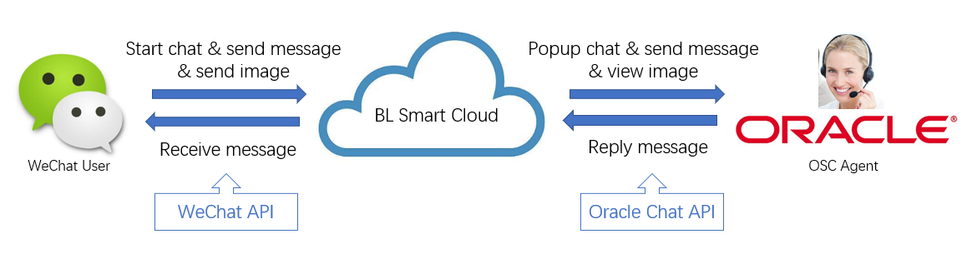

BL Smart Cloud is playing a critical role for the WeChat integration:

* It integrated with WeChat via WeChat API, support ‘button click’ to start chat
* It integrated with Oracle Service Cloud via Oracle Chat API, support ‘Screen Pop’ chat workspace with related student information such as mobile and pre-set WeChat fields & indicator
* It integrated with BL Image Cloud with both APIs, support ‘Online Image’ which allow agent to view the image online during the chat, as well as image ‘Auto Attachment Save’ in incident workspace

# Deployment Checklist

## Files

|  |  |  |
| --- | --- | --- |
| # | File Name | Comments |
| 1 | Handlers.zip | Time to install: 5 minutes |
| 2 | Reports.zip | Time to install: 5 minutes |
| 3 | Workspaces.zip | Time to install: 5 minutes |

## Profile Permissions

Locate the WeChat profiles:

* Support Agent – China
* Support Manager – China

Enable the Profile permissions as below:

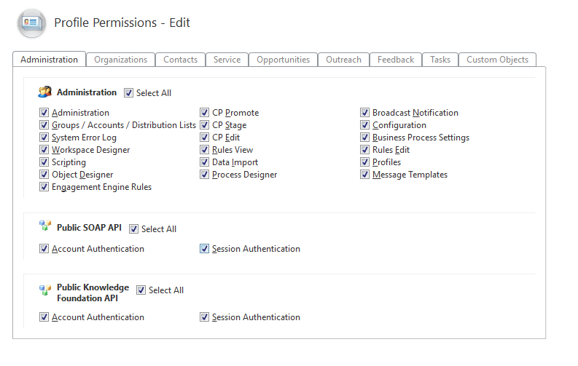

## Contact Custom Fields

Open the Custom Fields component. Create a Custom Field as below

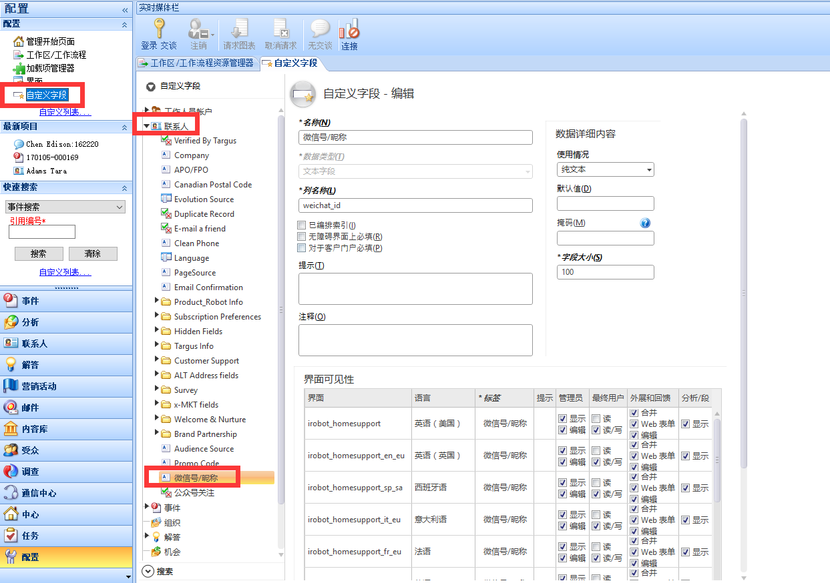

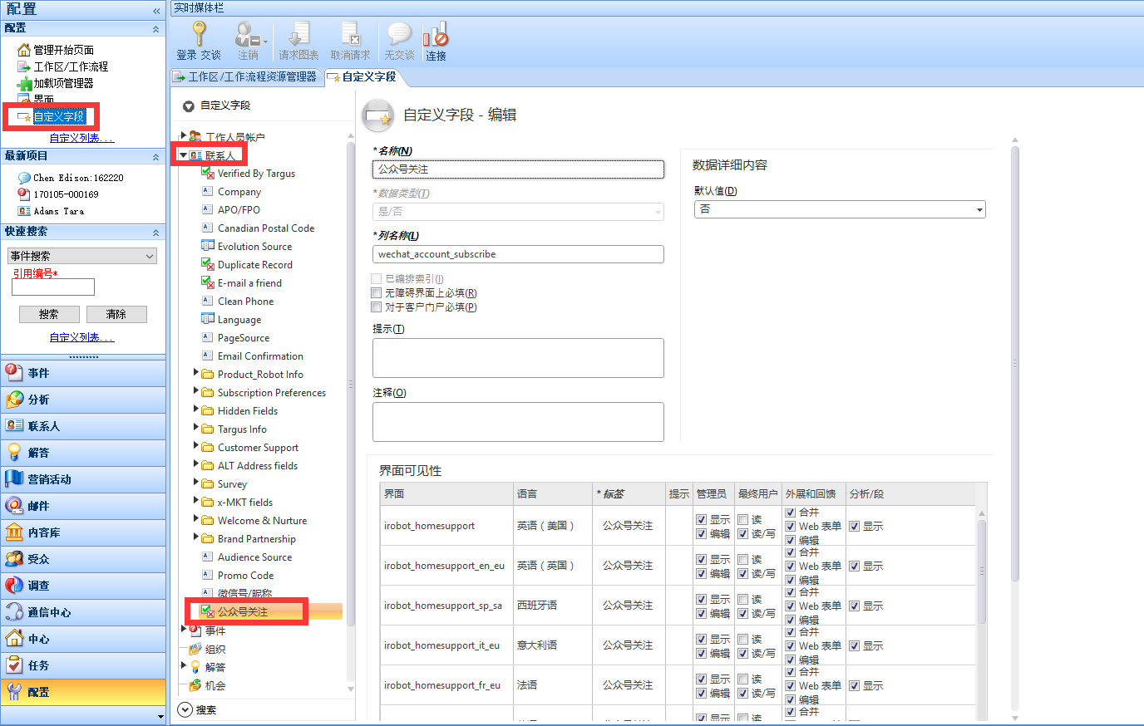

## workspace and workspace rule

### Contact workspace

Export the Contact workspace definition files

Location: \工作区和工作流程\x_Ting\ Agent Contact - China

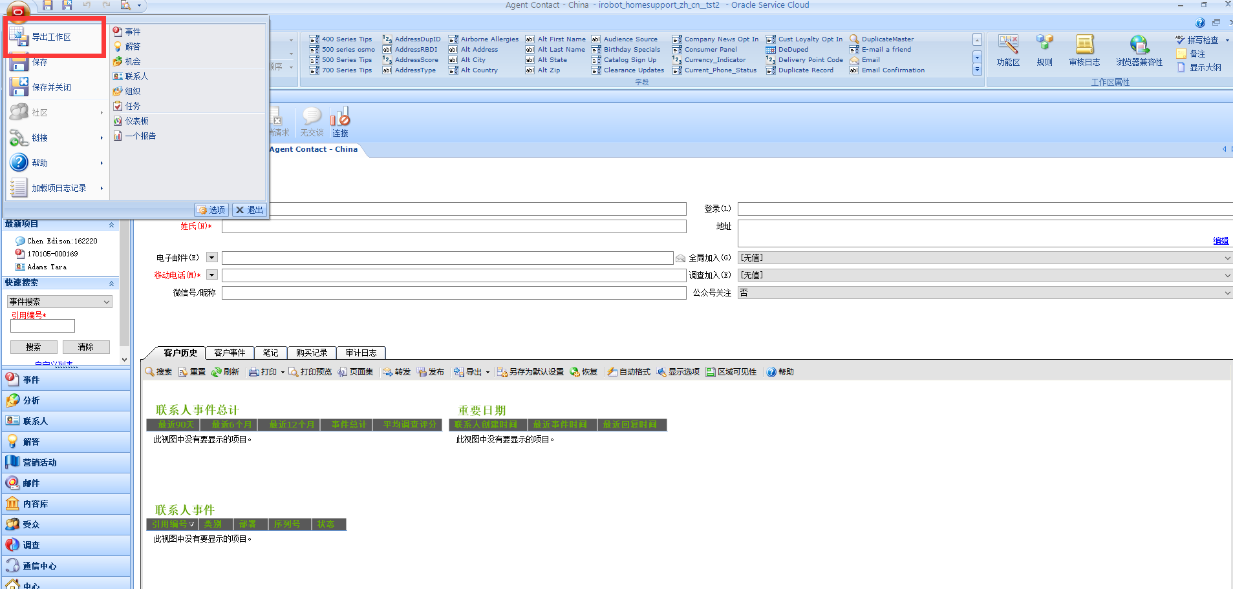

Open the Workspaces and Workflows component, Import the Contact workspace definition files.

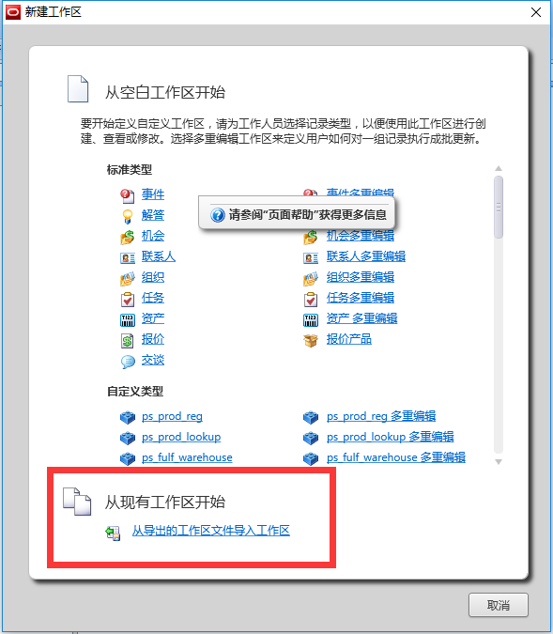

|  |  |
| --- | --- |
| Workspace Name | Workspace Definition File |
| Agent Contact - China | Agent Contact - China.xml |

Note:

1. Insert image control
2. Adjust image setting, uncheck auto adjust

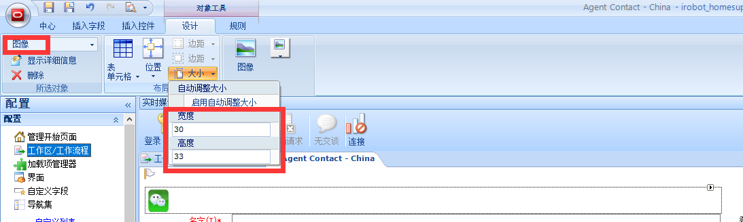

Select image

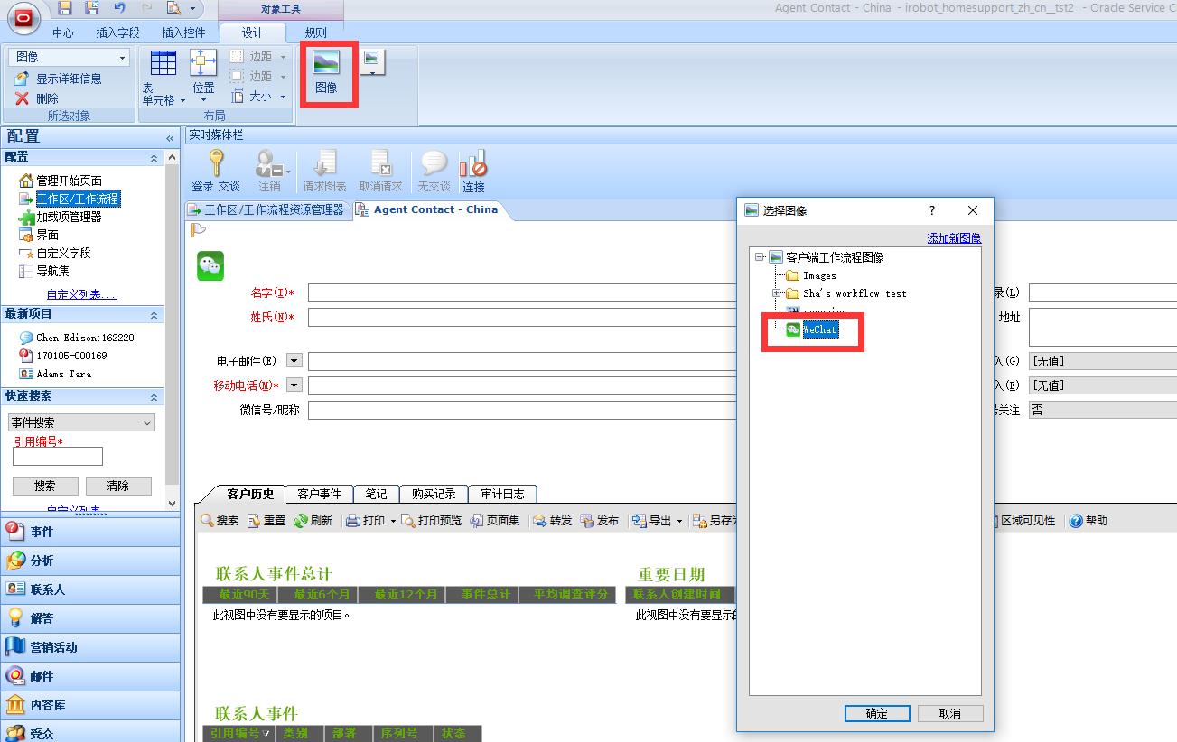

Adjust image display option

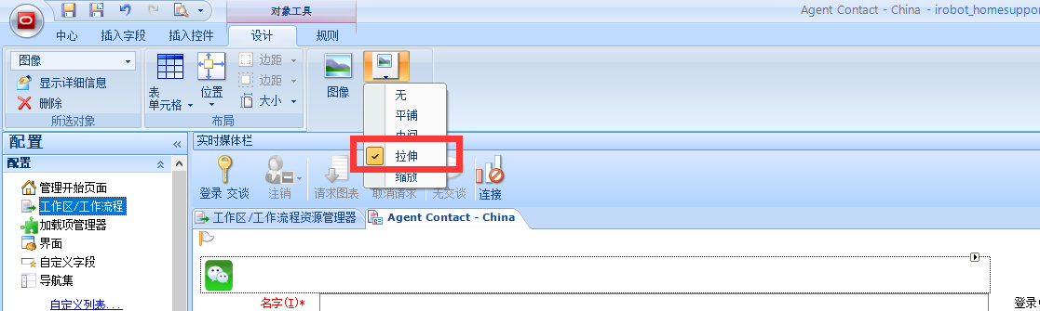

1. Insert custom field



1. Add new rule

Add a new workspace rule as below – Displays the WeChat icon when someone is chatting via wechat.

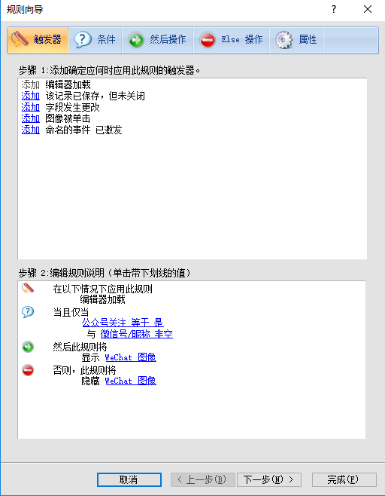

### Incident Workspace

Export the Incident workspace definition files

Location: \工作区和工作流程\x_Ting\ Support agent – China

\工作区和工作流程\x_Ting\ Support Manager-China

Open the Workspaces and Workflows component, Import the Incident workspace definition files.

|  |  |
| --- | --- |
| Workspace Name | Workspace Definition File |
| Support agent – China | Support agent – China.xml |
| Support Manager-China | Support Manager-China.xml |

Add a new workspace rule as below



### Chat Workspace

Open the Workspaces and Workflows component, Import the chat workspace definition files.

|  |  |
| --- | --- |
| Workspace Name | Workspace Definition File |
| 交谈 - BlueLeap | 交谈 - BlueLeap.xml |

Add a new workspace rule as below

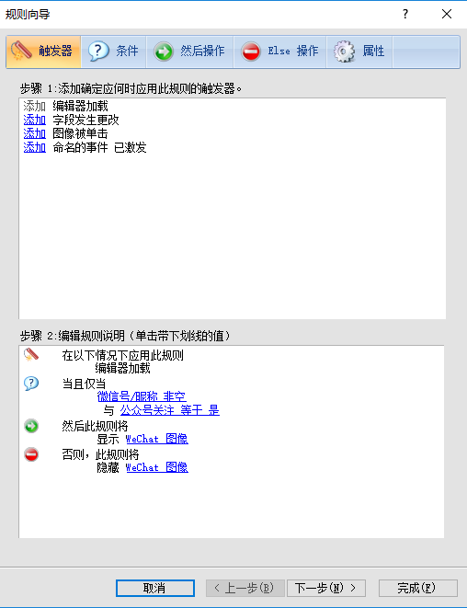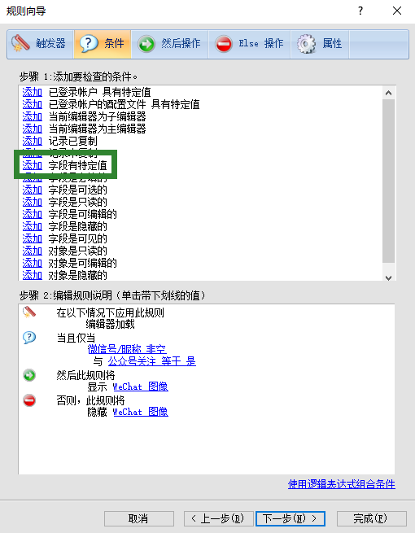

Add mobile number Fields

## Chat Reports

Open the Reports Explorer component, create a folder called ‘Approved Call Center Reports’ at the following location by importing definition files.

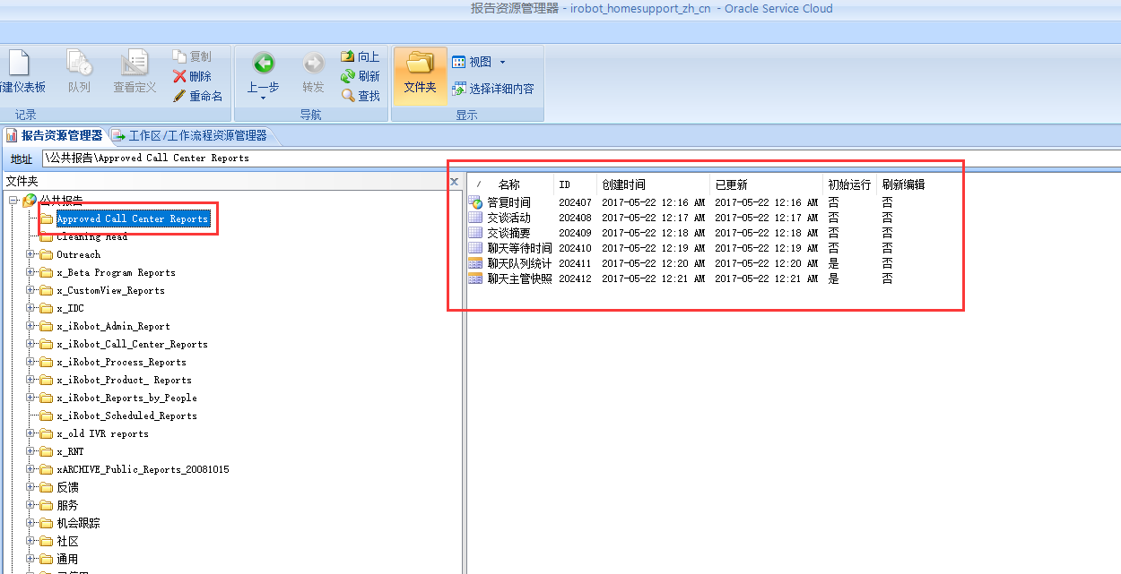

Create six reports by importing definition files

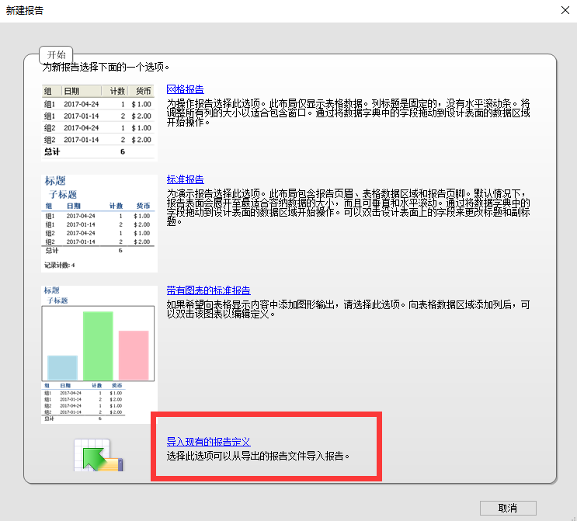

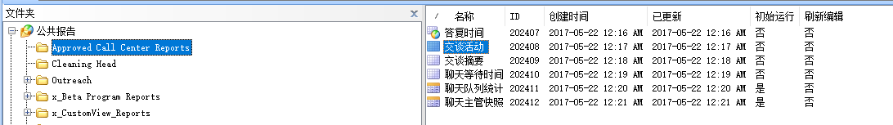

### Reports ID in Approved Call Centre Reports

|  |  |  |  |
| --- | --- | --- | --- |
| ID | Report Name | Report Name in Chinese | Report Definition File |
| 202407 | Response Time | 答复时间 | 答复时间.xml |
| 202408 | Chat Activity | 交谈活动 | 交谈活动.xml |
| 202409 | Chat Summary | 交谈摘要 | 交谈摘要.xml |
| 202410 | Chat Wait Time | 聊天等待时间 | 聊天等待时间.xml |
| 202411 | Chat Queue Statistics | 聊天队列统计 | 聊天队列统计.xml |
| 202412 | Chat Supervisor Snapshot | 聊天主管快照 | 聊天主管快照.xml |

## Object Event Handlers

### Background

We have deployed the WeChat Integration Phase I into iRobot system for Chinese support team, now we are providing the ability of sending images via WeChat by customers, and allow agent to see images in real time during the chat.

### Import Handler

1. Open the ‘Process Designer’

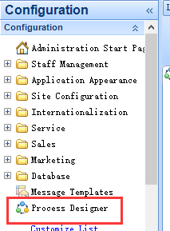

1. Import the zip file as below:

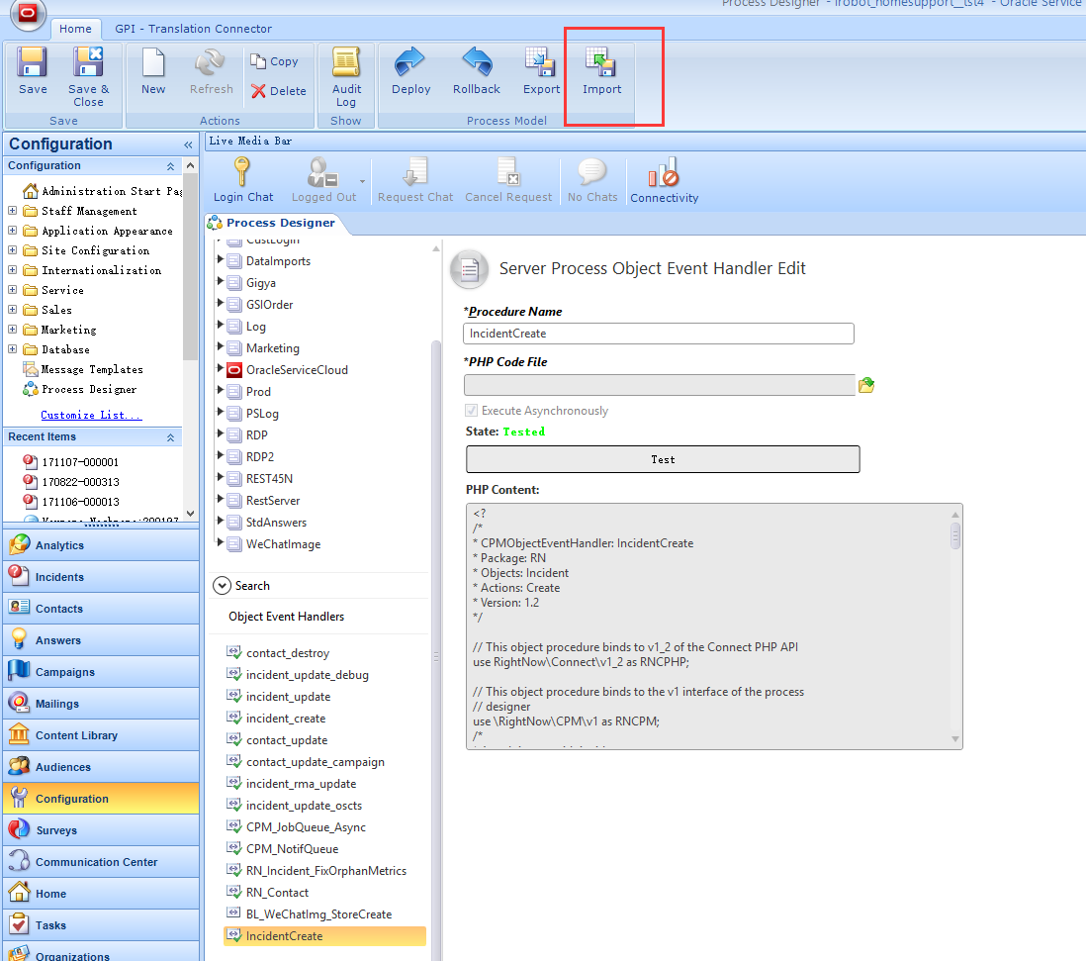

1. Save and Click the ‘Test’ button

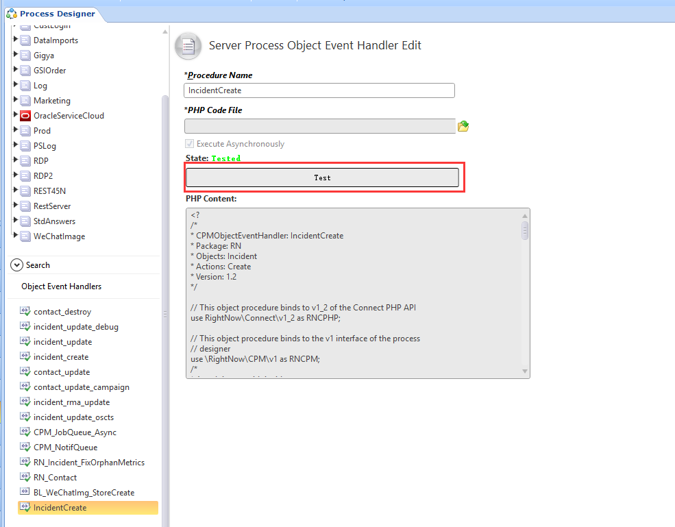

1. Click ‘Deploy’

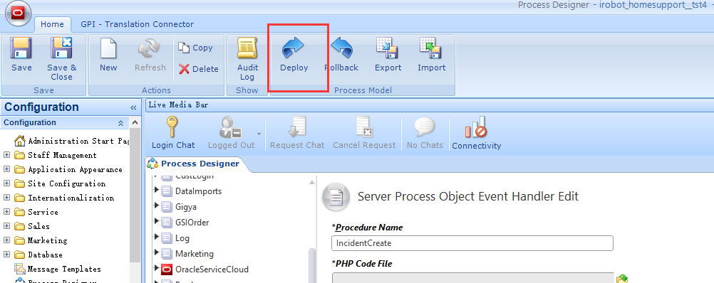

Refer to the exported zip file:

|  |  |
| --- | --- |
| Package Name | Package File |
| IncidentCreate | IncidentCreate.zip |

### Mapping the Process Model

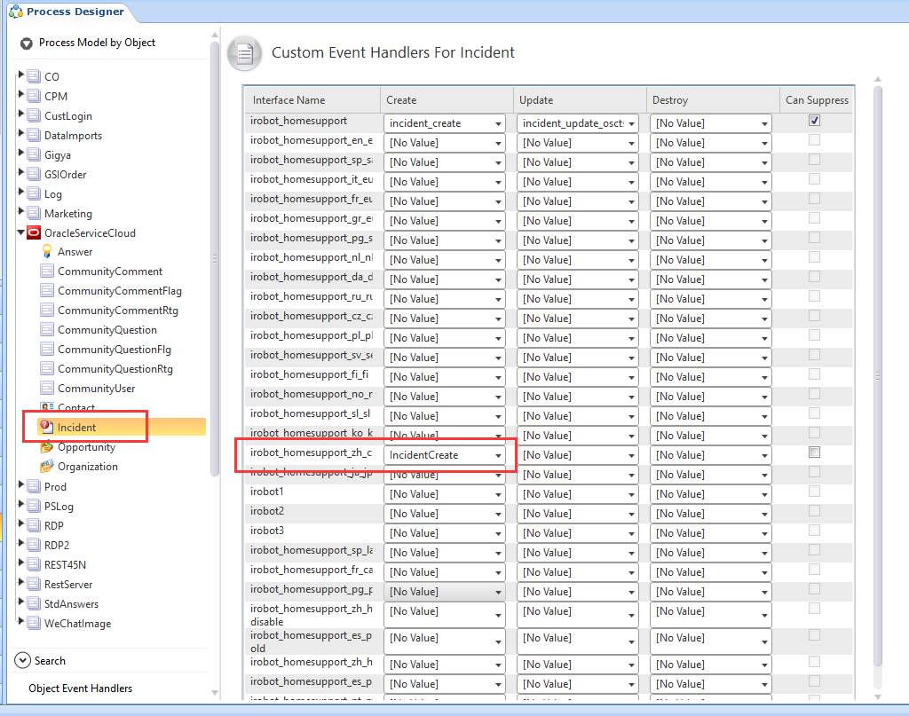

## BL Smart Cloud Setup

### Create new WeChat account

TBD